Given an array **H** representing heights of buildings. You have to count the buildings which will see the sunrise (Assume : Sun rise on the side of array starting point).

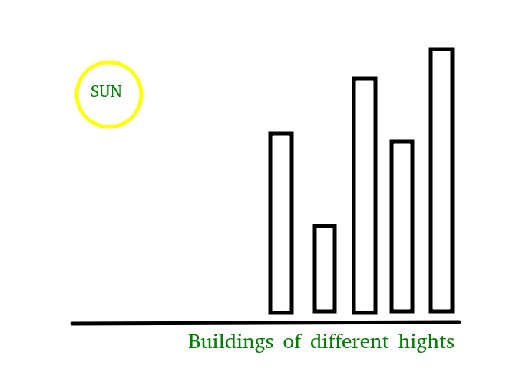

**Example 1:**

**Input:**

N = 5

H[] = {7, 4, 8, 2, 9}

**Output:** 3

**Explanation:** As 7 is the first element, it

can see the sunrise. 4 can't see the

sunrise as 7 is hiding it. 8 can see.

2 can't see the sunrise. 9 also can see

the sunrise.

--------------------------------------------------------------------------------------------------------------------------------------------------------------------------------------------------------------------------------------------------------------

// { Driver Code Starts

#include <bits/stdc++.h>

using namespace std;

// } Driver Code Ends

//User function template for C++

class Solution{

public:

// Returns count buildings that can see sunlight

int countBuildings(int h[], int n) {

// code here

int c=1;

int f=h[0];

for (int i=1;i<n;i++)

{

if(h[i]>f)

{

c++;

f=h[i];

}

}

return c;

}

};